ØØ Explanation :
- We are given a series of numbers. The length of series is stored at memory location D000 H. We will initialize register C as counter with the length of the series.
- We will initialize the accumulator with 00 H, so that the sum can be stored in the accumulator. Also initialize register B = 00 H so that the higher byte of sum can be stored.
- The series begins at D001 H. So, we will initialize HL the register pair as memory pointer to point the series.
- Using add instruction, add the contents, of the accumulator with the contents of memory location pointed by HL register pair. The result of this addition will be stored in the A register.
- Check for carry. If carry is 1 then increment register B.
- Then we will increment HL to point to next memory location of the series. Decrement the count in register C. Continue this process till the count is zero i.e. all the numbers in the series are added.
- Store the result at memory locations E000 H and E001 H.
ØØ Algorithm :
Step I : Initialize the register C with count.
Step II : Initialize sum in accumulator = 00 H and register B =00 H.
Step III : Initialize the pointer to memory location D001 H i.e. first number of series.
Step IV : Add the numbers in series.
Step V : Increment memory pointer to next memory location.
Step VI : Check for carry. If carry = 1 goto step VII else goto step VIII
Step VII : Increment register B
Step VIII : Decrement count
Step IX : Check if count = 0, if not goto step IV
Step X : Store the result at memory locations E000 H and E001 H.
Step XI : Stop.
ØØ Flowchart : Refer flowchart 16.
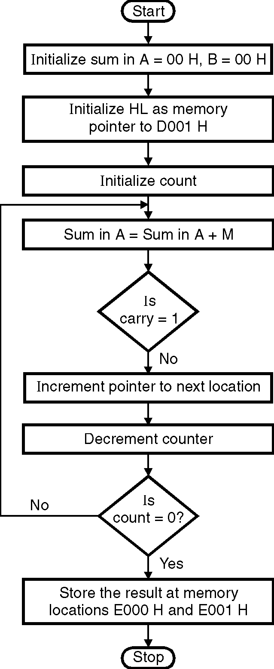
ØØ Program :
Instruction Comment
LDA D000 H ; A = contents of location D000 H
MOV C, A ; Initialize counter
XRA A ; sum = 0
XRA B ; sum in B = 0
LXI H, D001H ; Initialize HL as memory pointer
; for the series
L1: ADD M ; SUM in A= SUM in A + M
JNC L2 ; Check for carry
INR B ; Carry is incremented as MSB
; in register B.
L2 : INX H ; Increment pointer
DCR C ; Decrement counter
JNZ L1 ; if counter 0 repeat
STA E000H ; store the result at memory
; location E000 H
MOV A, B ; Store the MSB of result in
; register B
STA E001H ; store the result at memory location
; E001 H
HLT ; Terminate program execution Flowchart 16

